4/16/2024

Venkata Vikranth Jannatha – ST10053561

PROG7311 POE

Part 1

Table of Contents

Purpose of the ‘Agri-Energy Connect Platform’ Project 3

Introduction on Non-functional Requirements Analysis 3

Significant Non-functional Agri-Energy Connect Platform Requirements 4

Scalability 4

Strategies related to Non-Functional Performance Requirements Implementation 5

Planning and Strategy Execution for the Development of ‘Agri-Energy Connect’ Platform 5

Significant Non-functional Agri-Energy Connect Platform Requirements 6

Security 6

Strategies related to Non-Functional Performance Requirements Implementation 7

Planning and Strategy Execution for the Development of ‘Agri-Energy Connect’ Platform 8

Significant Non-functional Agri-Energy Connect Platform Requirements 9

Usability 9

Strategies related to Non-Functional Performance Requirements Implementation 10

Planning and Strategy Execution for the Development of ‘Agri-Energy Connect’ Platform 11

Significant Non-functional Agri-Energy Connect Platform Requirements 12

Performance 12

Strategies related to Non-Functional Performance Requirements Implementation 13

Planning and Strategy Execution for the Development of ‘Agri-Energy Connect’ Platform 14

Role of Design and Architecture Patterns for the Agri-Energy Connect Platform 14

Integrating Design and Architecture Patterns into the Agri-Energy Connect Platform Project 15

Microservices 15

Justification for Applying Microservices Pattern in Agri-Energy Connect Platform 16

Conclusion: 17

References 18

Table of Figures

Infographic 1 : Scalability Infographic (AltexSoft , 2023) 4

Infographic 2 : Security Infographic (AltexSoft , 2023) 6

Infographic 3 : Usability Infographic (AltexSoft , 2023) 9

Infographic 4 : Performance Infographic (AltexSoft , 2023) 12

Infographic 5 : Microservice Architecture (Ozkaya, 2023) 15

Figure 1 : Scalability Implementation (Co-pilot designer | Microsoft, 2024) 5

Figure 2 : Security Implementation (Co-pilot designer | Microsoft, 2024) 7

Figure 3 : Usability Implementation (Co-pilot designer | Microsoft, 2024) 10

Figure 4 : Performance Implementation (Co-pilot designer | Microsoft, 2024) 13

# Purpose of the ‘Agri-Energy Connect Platform’ Project

The 'Agri-Energy Connect' platform project aims to transform South Africa’s agriculture sector by encouraging sustainable practices and the implementation of green energy solutions through an innovative digital platform. The project aims to promote collaboration between farmers, green energy professionals, and enthusiasts by promoting knowledge sharing, innovation, and improving access to green energy and sustainable agriculture resources. The project’s overall goal is to enable stakeholders to adopt sustainable practices, increase efficiency, and contribute to the long-term sustainability of the agricultural industry.

## Introduction on Non-functional Requirements Analysis

It is crucial to have a good non-functional requirement for the success of the ‘Agri-Energy Connect Platform’, such as ‘Scalability, Security, Usability, and Performance’ which helps the platform to form the development approach and influence the software planning and execution. The goal is to consider the non-functional requirements and suggesting implementing the practical strategies for them execute the process to lay the foundation for a strong and efficient platform that not only meets the needs of various users but also contributes to the development of good environment practices and technology advances in agriculture sector (CodiumAI Team, 2024).

In this section, it will be discussed on Each non-functional requirement by explaining of critical success of having that non-functional requirement and how it must implement in the platform to provide the achieving output and providing the reasons how do we shape our planning and execution to the platform.

## Significant Non-functional Agri-Energy Connect Platform Requirements

### Scalability

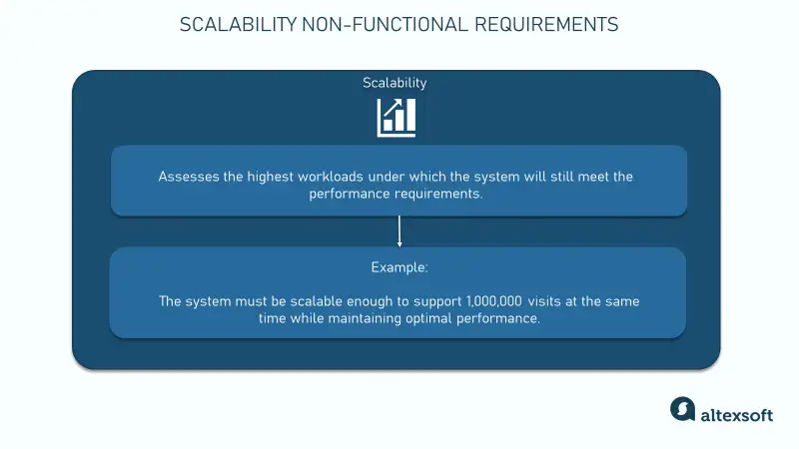

Infographic 1: Security Information (AltexSoft , 2023)

As the IIE (2024, pp. 22 - 23) explains that managing increased traffic and data loads while effectively supporting a growing user base and expanding functionality is inevitable for this platform. The main aim of the platform is to unite farmers and handle vast amounts of data and interactivity, and that is why the necessity of scaling is most significant.

Scalability ensures that the platform can flow as number of users or farmers and features expand while still works well. This system is planned to link many farmers and manage huge data quantities and interactions, so the ability for it to handle rising traffic and data loads is crucial. Therefore, the platform’s success is dependent on how well it can grow together with the increasing numbers of farmers who use it and it’s expanding features.

## Strategies related to Non-Functional Performance Requirements Implementation

Figure 2 : Scalability Implementation (Co-pilot designer | Microsoft, 2024)

Adopting scalable structures is an essential part in scaling up. To achieve it, a Scalability Database is recommended by One CoreDev IT, Inc (2023). By distributing data and handling read and write operations, it operates well under heavy traffic and large volume data, hence ensures seamless performance platform.

Furthermore, system design must develop load balancers. Integrating them helps distribute network traffic across many servers thereby increasing platform responsiveness and availability to users, hence helping to handle heavy traffic as much as possible so that people always see same things every time they visit or else it may not expand or survive over time.

## Planning and Strategy Execution for the Development of ‘Agri-Energy Connect’ Platform

The software development approach for the ‘Agri-Energy Connect’ platform needs to be exactly planner concentrating on building and testing of non-functional requirements. This should involve allocating sufficient time for setting up and installing ‘scalable database’ and ‘load balancers’ together with stress testing and performance adjustment as mentioned in Emily (2023).To achieve these goals, technologies and architectures used should be suitable for scalable database as well as for load balancers. System performance monitoring procedures need to be done regularly so that as it expands, scalability is maintained in a way that ensures that the system remains scalable.

## Significant Non-functional Agri-Energy Connect Platform Requirements

### Security

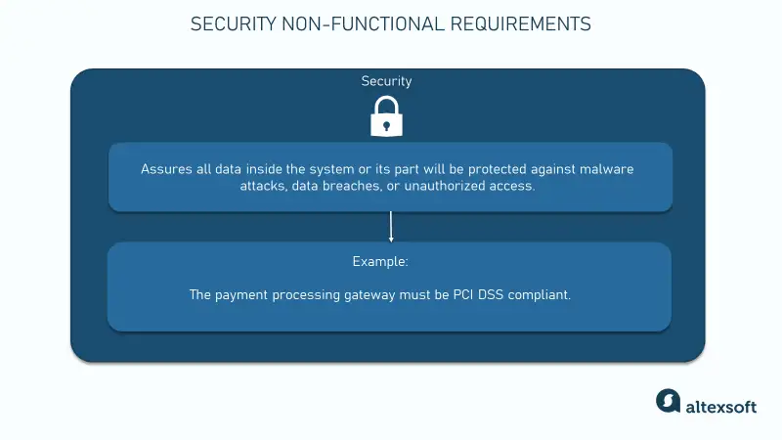

Infographic 2 : Security Infographic (AltexSoft , 2023)

IIE (2024, p. 24) says that prioritizing data security is essential to protecting sensitive information specifically in the sectors of agriculture, energy, and user stored within the platform. For the users, this is a main reason why they trust and choose to make dealing with this platform since they are guaranteed of its security which eventually ensures that their data is not hacked into this platform. It is essential for maintaining an excellent reputation for the platform and keeping users positive about it. This can enable more people to sign up and participate in enhancing its platform growth. Security measures would thus be implemented effectively to prevent and minimize expenses related to complaints associated with data breaches.

## Strategies related to Non-Functional Performance Requirements Implementation



Figure 3 : Security Implementation (Co-pilot designer | Microsoft, 2024)

If platforms are to achieve high-level security, specific strategies must be implemented, as outlined in (Sasovets, 2024).

**Authentication**: Applying secure method of logging in for user identity checks control usage and guard against illegal use.

**Data Encryption**: We will use the most advance encryption methods for user information to be kept confidential and integrity, secure from unauthorized access and corruption.

**Access control**: To prevent unauthorized users, to safeguard confidential information, and secure the entire platform, the Role-Based Access Control (RABC) will be used to set access levels depending on the user’s roles.

**Compliance**: For data security and privacy, the platform will adhere to the necessary industrial standards and laws. High data protection standards will be upheld through regular compliance checks which help to detect and mitigate vulnerabilities.

## Planning and Strategy Execution for the Development of ‘Agri-Energy Connect’ Platform

The development process will affect planning and execution in terms of how security requirements will be achieved. To secure the platform at a higher level, we will employ specific strategies based on Djik (2023)

* **Authentication**: Every verified user will be required to utilize secure login features to prevent unauthorized access.
* **Data Encryption**: Implementation of contemporary encryption methods will assure data privacy and integrity.
* **Access Control**: The use of role-based access is aimed at enhancing security by restricting unauthorised users from entering vital information.
* **Compliance**: Consistent adherence to industry standards will promote user trust and periodic reviews will reduce related dangers and assure enduring security of data.

These steps will direct the developmental strategy, so security is incorporated into every stage of planning and implementation. This will be achieved by tackling the major security issues for Agri-Connect Energy System, and therefore will uphold its defensibility from possible threats, ensuring safety as well as integrity.

## Significant Non-functional Agri-Energy Connect Platform Requirements

### Usability

Infographic 3 : Usability Infographic (AltexSoft , 2023)

The Agri-Energy Connect platform is created with the main aim to be easily used by people with different skills level concerning technology. For the platform to have high performance it is very important that it is simple to use because this affects how satisfied and active users will be (The IIE, 2024, p. 25). Simple platforms lower the time required for users to understand how to operate it which in turn raises working rates and subsequent involvement of users. However, a platform that is hard to use can make users feel angry and less likely to participate.

## Strategies related to Non-Functional Performance Requirements Implementation

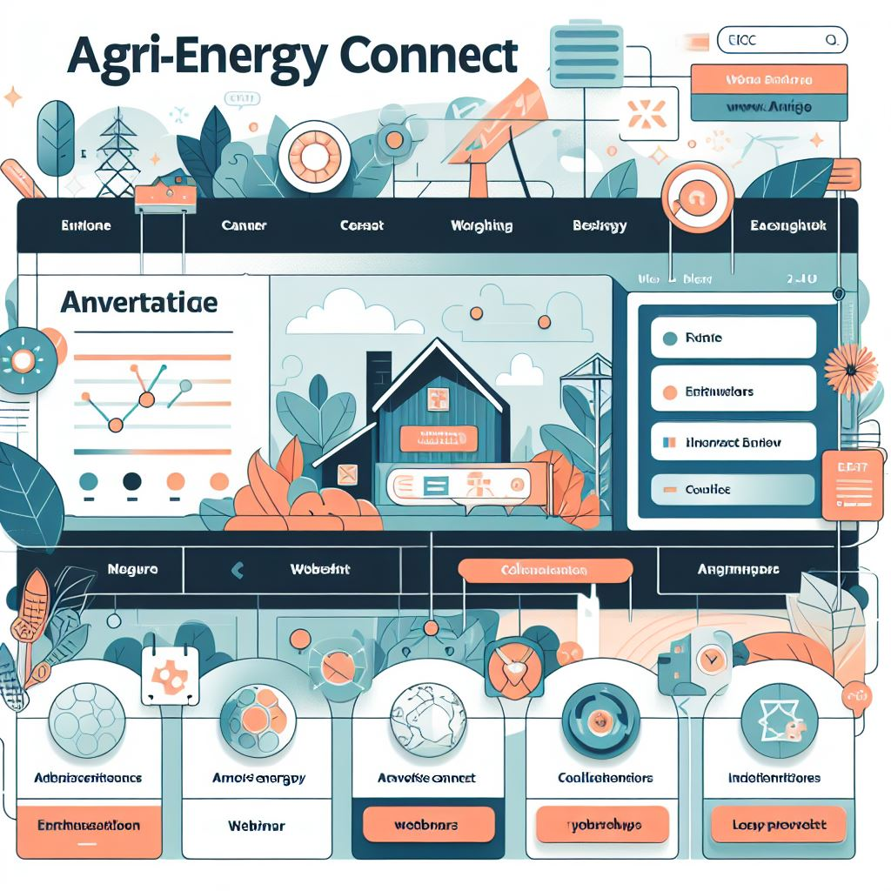

Figure 4 : Usability Implementation (Co-pilot designer | Microsoft, 2024)

To Achieve Good Usability, here are some strategies for improving the usability of the ‘Agri-Energy Connect’ platform based on NewHouse (2022):

**Easy Navigation**: A structured menu and search tools can help users quickly find the info they require. For the Sustainable Farming Hub, Green Energy Marketplace, and educational resources, having separate sections in the menu makes it much more user-friendly.

**Consistent Design**: Users can quickly understand and navigate various pages with the help of a consistent design on the platform that includes Color schemes, typography as well as layout. It enhances user experience when the same styles are used leading to improvement in user awareness and making the site easier to work with.

**Clear Info to action**: Giving users straightforward and directed information in the platform helps them move around and engage with more functions confidently. For instance, showing users how to join webinars or workshops, as well as work together on projects, improves usability because it becomes more self-explanatory.

## Planning and Strategy Execution for the Development of ‘Agri-Energy Connect’ Platform

When creating the Agri-Energy Connect Platform, the key thing is to ensure that it is easily used. According to Fender (2024), the major concern will be making sure that they come up with an interface which is user friendly; visually attractive as well as simple enough for everyone who wants to access any information on that site can do so without having much trouble looking for it. User needs will also be taken into consideration while determining how information is structured to facilitate easy retrieval of materials necessary for their work performance. This will also help in reducing the chances of coming up with irrelevant pieces thereof. They will have smooth interaction flows and enable users’ complete tasks more efficiently and satisfactorily than before. While creating the platform, focus will be on user needs and desires leading to one that is tailored specifically for the target audience as well as providing information purposes effectively (Fender, 2024).

## Significant Non-functional Agri-Energy Connect Platform Requirements

### Performance

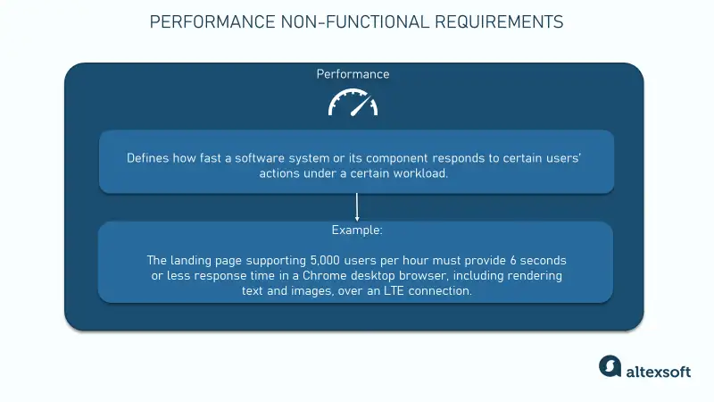

Infographic 4 : Performance Infographic (AltexSoft , 2023)

The Agri-Energy Connect Platform's success lies in its speed and reliability which have a direct impact on user satisfaction and engagement. Therefore, for one to attract users, they must optimize how it performs to make it more responsive and dependable as discussed in IIE (The IIE, 2024, pp. 21 - 22). This will also greatly improve user experience. Satisfying user connections make the platform grow. It helps user to trust and support, and not merely technology implementation must become performance requirements in the platform.

## Strategies related to Non-Functional Performance Requirements Implementation



Figure 5 : Performance Implementation (Co-pilot designer | Microsoft, 2024)

To achieve Performance, here are the strategies will be implemented in platform based on (Khullaar, 2023)

**Implement Caching**: Enabling the platform to handle data and user interactions in a more efficient way is a key advantage of caching. Load times become shorter when caching is used, making the platform more effective despite server load conditions encountered by end-users. Such examples include deploying server-side caching for dynamic content like community messages, which results in quicker information access and better user experiences.

**Optimizing Database Queries and Indexing**: This feature is crucial for platforms, especially forums and project collaboration areas, that need frequent data retrieval and updates. Things like often-used data indexing and introducing paging are some of the ways to make a platform faster without overloading its database server. All these things combined help in making sure that data is processed easily and smoothly thereby improving the user experience.

**Conduct Performance Testing and Optimization**: To maintain good performance of the platform, it is necessary to constantly test and optimize its performance. These steps include load testing as a way of finding possible performance bottlenecks, code profiling which is about making your code more efficient and continuous monitoring. Doing so helps us ensure that the platform is efficient even as information volume and user numbers increase.

## Planning and Strategy Execution for the Development of ‘Agri-Energy Connect’ Platform

Performance primarily determines the massive design of the Agri-Energy Connect Platform. Warren (2018) observed that need to handle multiple user requests, processing data quickly and provide smooth user experience greatly impacts on the choice of technologies, frameworks, infrastructure components used in development. For example, caching improves responsiveness especially when managing data and user interactions. Furthermore, enhancing database query optimizer and indexer increase speed and reduces CPU pressure quite critical areas that require consistent data getting and changing. Regular performance testing together with checking the platform in terms of load testing, code profiling, and then following to ensure along usage increases maintain the high performance of the platform and data volume (Warren, 2018).

## Role of Design and Architecture Patterns for the Agri-Energy Connect Platform

The development of the ‘Agri-Energy Connect’ Platform hinges on design and architectural patterns, particularly in the context of ‘Microservice Architecture’. These provide structured solution to common design problems and facilitate efficient organization of system components (Montalván Horta, 2023). Consistency, maintainability, and scalability are ensured by design patterns in this project whereas architecture patterns guide the overall structure and functionality of the platform. These very same patterns are not only meant to simplify the development process but make sure that the platform remains durable, adaptable, and flexible even in the face of changing requirements. As such, they are not merely important; they are critical to the success of this project.

## Integrating Design and Architecture Patterns into the Agri-Energy Connect Platform Project

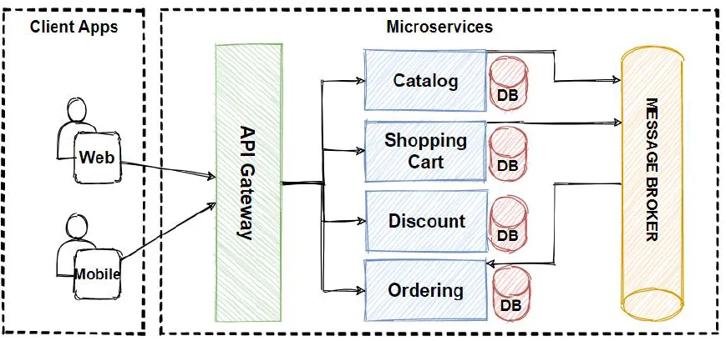

Infographic 5 : Microservice Architecture (Ozkaya, 2023)

### Microservices

The ‘Agri-Energy Connect’ Platform uses ‘Microservice Architecture, where the system is broken apart into smaller services, allowing each to operate independently within Sustainable Farming Hub, Green Energy Marketplace & Educational Resources functionalities. This strategy allows treating every platform feature as an autonomous service relying upon the company’s portfolio and distributing (Google cloud, 2024) separately.

Microservice is built deployed and scaled individually thus providing the possibility to update faster improving performance and enhancing maintainability on the platform. As well as allowing flexible growth, it ensures that every service can expand according to user demand by exploiting resource to the maximum (Google cloud, 2024).

To achieve its primary objective – scalability, ease of maintenance, user experience (UX), flexibility, increased collaboration, and preservation – application of Microservice Architecture pattern is crucial in this context. Implementation of this design and architecture style improves operational efficiency on the platform as a whole (Google cloud, 2024).

## Justification for Applying Microservices Pattern in Agri-Energy Connect Platform

According to Skyrl (2023), using the ‘Microservice Architecture’ pattern is a crucial component of the ‘Agri-Energy Connect’ platform provides significant values, such as:

**Scalability:** The utilization of Microservice Architecture in ‘Agri-Energy Connect’ Platform gives room for scalability through which each service request can scale on its own. In terms of high peak periods, it allows for the effective management of resources and excellent performance as well as audience response by farmers, users, or green energy professional.

**Flexibility**: With the use of Microservice Architecture greater technology choices, development durations and upgrades are possible. New integrations become easier through this flexibility meaning that the platform can adapt to change without any disturbances to the whole system or need for support concerning rising needs or technological advances.

**Maintainability**: Maintenance and development are simplified through separating services using microservices architecture. This results in quicker development, simpler troubles shooting and improved long-term stability because individual teams can work on their assigned features independently enhancing speed in designing programming and diagnosis. The minimum disturbance on which the growth of the platform was based in this approach means that it is very reliable and capable of remaining stable.

**Enhanced Collaboration**: Microservice Architecture boosts the use of team through enabling several groups to simultaneously work on different services. Innovative thinking is promoted in this teamwork setup thus reducing development cycles as it leverages on specialist skills in particular service areas. This is because greater collaboration results to better feature implementation as well as user experience.

**Usability**: When complicated capabilities are divided into smaller, more manageable services, the platform becomes more user friendly using the Microservice Architecture. As a result, this ease of user interface operations enables users to search for relevant information, familiarize themselves with the platform as well as access features in tune with what they need.

## Conclusion:

A significant project aimed to address South Africa’s pressing need for sustainable agriculture and green energy utilization is the Agri-Energy Connect Platform. The main idea is to establish a digital ecosystem connecting agriculture to suppliers of green energy technologies which allows for a new way of collaboration and data exchange platform. It is important for the prosperity of this project to put into practice significant non-functional requirements such as scalability, security, usability, and performance and incorporating design patterns like Microservices with architectural patterns would make sure system maintenance.

The Agri-Energy Connect Platform is adaptable to the ever-changing developments in the agricultural sector and proves to show a dedication to eco-friendly farming methods, technological improvements, and community involvement. Through changing how farmers can use renewable energy sources thereby incorporating sustainable farming Next practices., its goal is bringing about positive changes within agriculture in general.

# References

AltexSoft , 2023. *Nonfunctional requirements: Examples, types and approaches.* [Online]   
Available at: https://www.altexsoft.com/blog/non-functional-requirements/  
[Accessed 30 Decemeber 2024].

CodiumAI Team, 2024. *Why are non-functional requirements important?.* [Online]   
Available at: https://www.codium.ai/blog/why-are-non-functional-requirements-important/  
[Accessed 15 April 2024].

Co-pilot designer | Microsoft, 2024. *Dalle 3.* [Online]   
Available at: https://www.bing.com/images/create/a-secure-digital-platform-with-authentication2c-dat/1-661e28f9f92e48fb9d5ef26bb02cc9a2?FORM=SYDBIC  
[Accessed 16 April 2024].

Djik, V. V., 2023. *Define security requirements for software development - 16 practices.* [Online]   
Available at: https://www.securityscientist.net/blog/define-security-requirements-for-software-development-16-practices/  
[Accessed 13 April 2024].

Emily, 2023. *Unveiling the power of scalability: A fundamental pillar in enterprise software architecture.* [Online]   
Available at: https://www.zonopact.com/blog/unveiling-the-power-of-scalability-a-fundamental-pillar-in-enterprise-software-architecture/  
[Accessed 8 April 2024].

Fender, A., 2024. *The importance of usability in software development.* [Online]   
Available at: https://www.chartsattack.com/importance-of-usability-in-software-development/  
[Accessed 11 April 2024].

Google cloud, 2024. *What is microservices architecture?  |  google cloud.* [Online]   
Available at: https://cloud.google.com/learn/what-is-microservices-architecture  
[Accessed 14 April 2024].

Khullaar, A., 2023. *Best practices for improving software performance.* [Online]   
Available at: https://www.linkedin.com/pulse/best-practices-improving-software-performance-amit-khullaar-1f/  
[Accessed 11 April 2024].

Montalván Horta, J. Y., 2023. *The importance of good architecture and Design Patterns for high-performance software.* [Online]   
Available at: https://www.linkedin.com/pulse/importance-good-architecture-design-patterns-software-jos%C3%A9-yadiel/  
[Accessed 14 April 2024].

Newhouse, R., 2022. *7 tips to improve your website usability and Design.* [Online]   
Available at: https://www.receptional.com/articles/7-tips-improve-websites-usability/  
[Accessed 10 April 2024].

One CoreDev IT, Inc, 2023. *10 tips for Crafting Scalable Software Solutions.* [Online]   
Available at: https://onecoredevit.com/news-and-insights/software-development/building-software-for-scalability-10-tips-and-strategies/  
[Accessed 8 April 2024].

Ozkaya, M., 2023. *Microservices architecture.* [Online]   
Available at: https://medium.com/design-microservices-architecture-with-patterns/microservices-architecture-2bec9da7d42a  
[Accessed 16 April 2024].

Sasovets, I., 2024. *10 steps to security in software development.* [Online]   
Available at: https://www.techmagic.co/blog/security-in-software-development/  
[Accessed 9 April 2024].

Skyrl, H., 2023. *7 benefits of microservices architecture to know about.* [Online]   
Available at: https://vilmate.com/blog/benefits-of-microservices-architecture/  
[Accessed 14 April 2024].

The IIE, 2024. *Programming 3A Module Manual.* 1st ed. Cape Town: The Indepedent Institute of Education.

Warren, T., 2018. *Performance requirements analysis 101.* [Online]   
Available at: https://tangowhisky37.github.io/PracticalPerformanceAnalyst/pages/spe_fundamentals/performance_requirements_analysis_101/  
[Accessed 13 April 2024].